**Scotland County Board of Education –Local Budget**

**__________________________________________________________**



**Dr. Ronald K. Hargrave**

**Superintendent**

**FY 2015-2016**

**Laurinburg, North Carolina**

www.scotland.k12.nc.us

Overview

Introduction

Board Of Education

Administration

Strategic Plan

**Update Information**

ADM At A Glance

School Information - Demographics

C.E.P Information

Transparency Grade

Local School Finance Study

Expenditure Summary

Fund Balance Analysis

Personnel Recap

Capital Outlay Recap

Local Recap

State Public School Fund Recap

All Funds Recap

Fines And Forfeitures Analysis

**Budget FY 15-16**

Budget Letter

Process/Calendar

Executive Summary

Total Budget (by source and by purpose)

2015/2016 Local Budget (Current Expense)

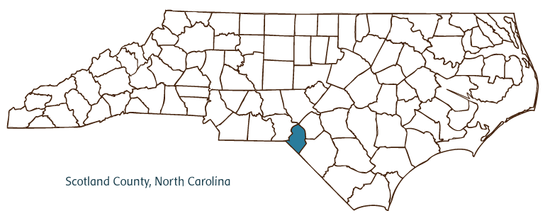2015/2016 Capital Outlay Project Request

Introduction

Scotland County Schools growth has continued to slide. The current slide has continued for the past three years. We are continuously faced with mounting pressures of state cuts and unfunded mandated programs. Scotland County Schools faces many opportunities and challenges and those are directly correlated to fiscal management and facility needs.

As we begin discussions on the budget and budgetary process it is necessary to keep focus on the initial tasks at hand;

**Our focal goals for FY 2014-15**

* Focus on data-driven instruction to improve student learning and achievement
* Professional development to build principal and teacher capacity
* Communication between all stakeholders
* Improve wireless infrastructure/capacity
* RtI/PBIS

We also strive to maximize our contribution to the economic factors outside of our school buildings

* The creation and facilitation of a globally and 21st century ready student.
* Providing economic opportunity to the residents of the county and surrounding area.
* *Providing the highest return on investment possible for the taxpayer’s money.*

We continuously work to streamline our goals with our financial outlays and make best use of the funding provided from the County to Scotland County Schools. Scotland County Schools resides as one of the top employers in the county, providing jobs for more than **900** employees. Therefore the funding provided from the county stimulates present economic activity. Throughout this presentation we will references the goals in our strategic plan to the relevant budget topics.

Scotland County Board Of Education

Chair: Dr. Jeff Byrd

District: Stewartsville

jeff.byrd@scotland.k12.nc.us

Term Expires 12/2016

Vice-Chair:  Pat Gates

District: Stewartsville

pgates@scotland.k12.nc.us

Term Expires 12/2016

Jamie Sutherland  
District: At-large  
jamie.sutherland@scotland.k12.nc.us  
term expires 12/2018  
  
Charles Brown  
 District: At-large  
 charles.brown@scotland.k12.nc.us  
term expires 12/2016  
  
Darrel "B.J." Gibson  
District: Stewartsville  
darrel.gibson@scotland.k12.nc.us  
term expires 12/2018  
  
Dr. Summer Stanley  
District: At-large  
sstanley@scotland.k12.nc.us  
term expires 12/2018  
  
Raymond Hyatt  
District: Stewartsville  
rhyatt@scotland.k12.nc.us  
term expires 12/2018  
  
 Wayne Cromartie  
District: Stewartsville  
wcromartie@scotland.k12.nc.us  
term expires 12/2016

Celebrations

*The district 2013-14 graduation rate was 78.3%.  This represents a growth of 5.5% from last year and the highest graduation rate ever for Scotland County Schools.  
  
*SEarCH was recognized by the NCDPI for an outstanding graduation rate for 2013-14 of  95.2%.   
  
*The 2013-14 drop out rate was 4.18%.  This represents a 1.22% decrease from the high of 5.4% in 2010-11.  
  
*At 84th out of 934 graded institutions, Scotland Early College High School ranked in the top 10 percent of high schools in Niche Rankings’ 2015 Best Public High Schools in North Carolina rating.  
  
*An area of significant improvement is our district’s Overall Performance Composite. This score is an indicator of students’ performance on End-of-Grade and End-of-Course tests. In 2012-13, Scotland County Schools’ Performance Composite was 37.1% compared to 2013-14 where our district’s Performance Composite increased to 49.5%.   Furthermore, 13 out of 14 of our schools improved their overall performance composite in 2013-14 as well.   
  
*A two-year pilot program is now underway at Scotland Early College High School, in which each freshman and sophomore is loaned a Chromebook for the duration of the school year with the expectation that having the constant 1:1 accessibility will lead to even more improved student achievement.  
  
*In the summer of 2014, Richmond Community College and Scotland County Schools celebrated an expanded partnership between the two institutions that paves the way for more students to take advantage of free college classes while still in high school. RCC now offers  a multitude of classes on the Scotland High campus through the Career and College Promise program. New programs offered to students this school year include mechanical engineering, computer information and engineering, business administration, mechatronics, electronics and industrial systems.    
  
*Covington Street Elementary, Laurel Hill Elementary, South Scotland Elementary, Spring Hill Middle, and Washington Park Elementary were recognized as 'Title 1 High Performance Reward Schools'.    
  
*All five of our schools that have Pre-K programs (IEJ, Laurel Hill, North Laurinburg, South Scotland, Washington Park, and Wagram) have earned the coveted 5 star ECERS rating.   
  
*Covington Street Elementary School earned 'exemplar status' for their implementation of the North Carolina Positive Behavior Intervention and Support (PBIS) initiative.  
  
*An average of 3,833 students ride our buses every day. Over 412,000 miles were driven in 2013-14 and there was not a single injury to a child was reported while transporting students.

A.D.M. At A Glance

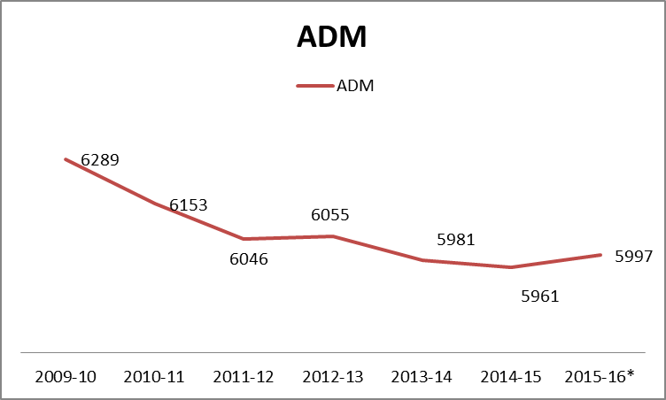

The decrease in ADM since 2002 has been nearly 800 children (ADM in 2002 was 6771). Furthermore the pressure the drop in ADM has had on the budget is substantial. The drop in ADM since 2009-10 has been 5% whereas the decrease in the budget has been 13%.

Update Information School Information &

Demographics





Scotland County Schools

Child Nutrition Program

C.E.P

**"Children must be healthy to learn ...........and they must learn to be healthy"**

* Part of the 2010 Healthy, Hunger Free Kids Act.
* Intent is to provide an alternative to household applications for free and reduced priced meals.
* Community Eligibility Program is to be available/ implemented nationwide beginning July 1, 2014.
* LEAs must meet a minimum level of 40% of identified students, agree to serve free breakfast and lunch to all students, not collect free and reduced lunch applications and agree to cover with non-federal funds any cost of providing free meals to all students above amounts provided in Federal assistance.
* Identified students are students certified for free meals through other means other than an application, SNAP, TANF etc. also includes homeless, runaway, Head Start and migrant youth.
* LEA may participate 4 years or opt out at the end of any year.
* **Based on current free/ reduced information Scotland County will qualify 100%.**

Through our **goal #4** “High PerformaC:\Documents and Settings\JTOLAND\Local Settings\Temporary Internet Files\Content.IE5\FEE7K7A6\MC900366658[1].WMFnce Learning Environments” we feel it is imperative that every child eats breakfast and lunch free of charge and C.E.P affords us that opportunity.

Transparency Grade

NCTransperency.com (John Locke Foundation)

24 base documents that the site tracks for public entities.

A – 6%

**Area Schools**

**Scotland County Schools – A**

Hoke County Schools – D

Richmond County Schools – D

Moore County Schools – C

Anson County Schools – D

Montgomery County Schools – C

Sampson County Schools – D

Cumberland County Schools – C

Harnett County Schools - D

The Board strives for the fullest level of transparency to provide all stakeholders a clear picture of the Board’s operations and decisions **(goal #3).**

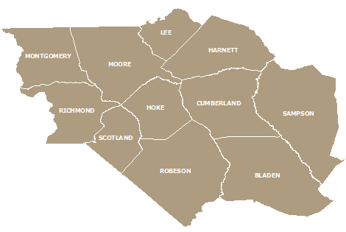

Local School Finance Study

*Public School Forum of North Carolina*

Total current spending per student – spending used for instruction-related costs and programs

2014 State Average – $1462.31

2014 Scotland County Schools – $1645.27

Actual Effort – reflects the actual dollar effort of communities to fund schools, **without** taking into account property wealth.

2014 State Rank – 25

2013 State Rank - 29

Actual Effort with Supplemental Funding – Counties are ranked by their total current spending **combined** with low wealth and small county supplemental funding.

2014 State Rank - 22

2013 State Rank - 23

Relative Effort-This compares actual effort and ability to pay

2014 State Rank - 1

2013 State Rank - 1

How Much Counties Spend on Education (% of Revenue)*

2014 State Average – 33%

2014 Scotland County – 27%

*Source – <https://www.nctreasurer.com/slg/Pages/County-and-Municipal-Financial-Data.aspx>

Fund Balance Analysis

Current Expense – Total



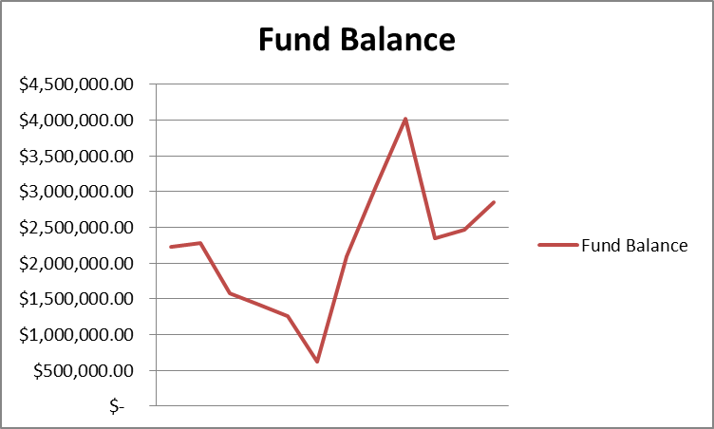

The Board of Education is maintaining a 3% unrestricted fund balance on all funds and a 14% on local funds. The board monitors fund balance closely maintaining a balance of this year’s money for this year’s children while staying on a track to avoid insolvency.

Fund Balance Analysis

Capital Outlay



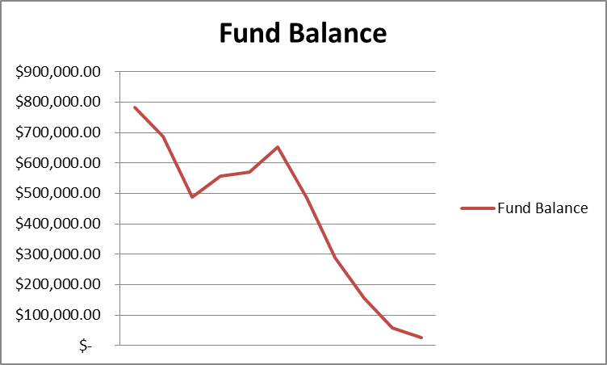

The Board’s capital outlay fund balance has dropped 97% or $756,125 in the past ten years. This remains a concern due to the lack of visibility the board has in potential building failure and an aging activity bus fleet. The board’s average age of building is 45 years old.

Personnel Recap & Update 2014-2015



Through our **goal # 1** in our strategic Plan “High Performance Students” we use our staffing strategy to employ positions that directly affect children; this is evident through the top three categories of employees being elementary and secondary teachers and teacher assistants.

Capital Outlay Recap & Update 2014-2015



C:\Documents and Settings\JTOLAND\Local Settings\Temporary Internet Files\Content.IE5\S4ATOSYO\MC900324808[1].WMF

Current Expense Recap 14-15

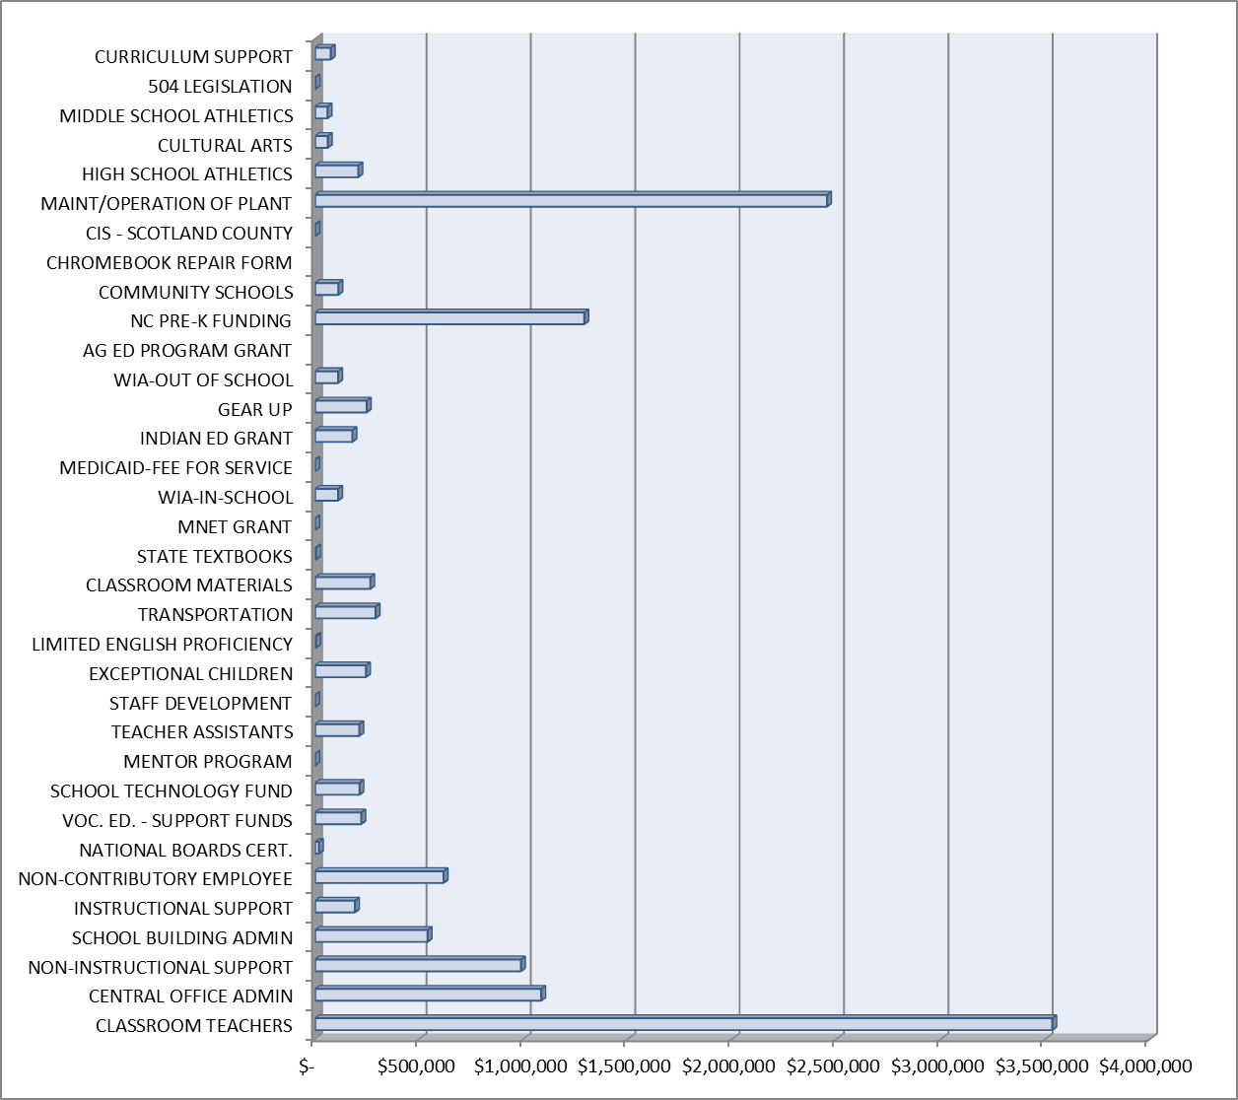

The current local budget equals 13.3 million with the majority of the expenditures in classroom teachers (**goal #1**) and maintenance (**goal #4**) (which is required by state law to be paid out current expense). We also fund **goal #3** High performance communication through the Public Information Officer’s Office.

State Public School Fund Recap 2014-15

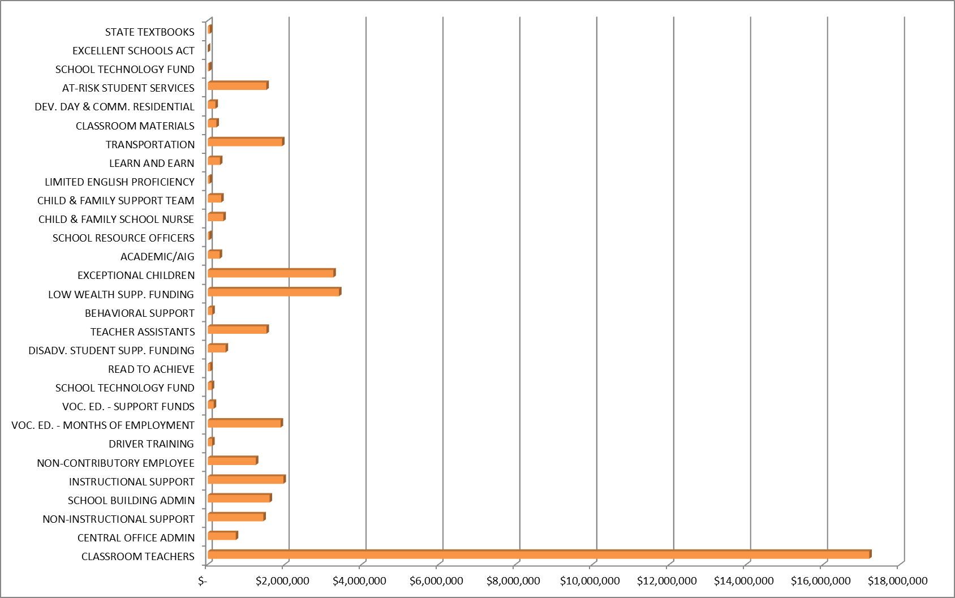

The State Public School Fund current totals 40.7 million and the majority of the budget is allocated too classroom teachers, low wealth initiates (where we fund **goal #2** “High Performance Staff” through powerful staff development using researched best practices) and exceptional children.

 All Funds Recap 2014-15

Fines & Forfeitures Analysis

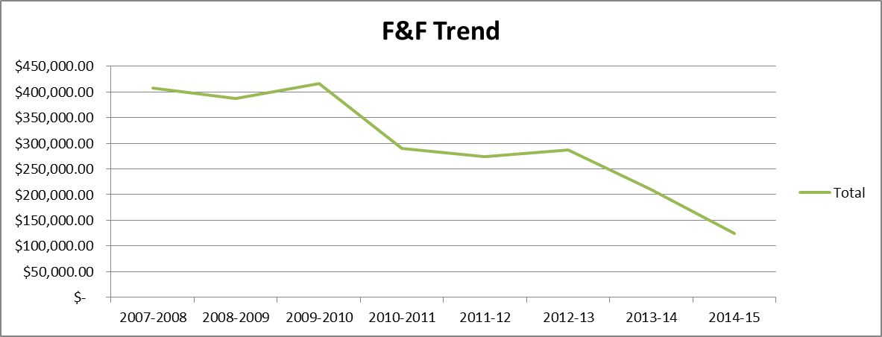

Fines and Forfeitures continue to drop. The Board currently budgets all Fines and Forfeitures to the capital outlay fund, which in turn leads to more pressure on the capital outlay fund due to the drop in revenue from Fines and Forfeitures.

Budget Letter

BUDGET MESSAGE

**2015-2016**

|  |  |  |  |
| --- | --- | --- | --- |
| |  | | --- | | The Scotland County Schools Board of Education and administrative staff present for your consideration the proposed Scotland County Schools budget for fiscal year 2015-2016. The proposed budget will allow us to continue providing the educational services expected by our community and essential to our students’ success in colleges and careers. The proposed budget includes no expansion items. Instead, it allows us to maintain current educational programs by preventing additional staffing reductions and by avoiding the elimination of valuable student services.  The local current expense budget reflects an increase of $212.287 from the 2014-2015 approved appropriation as a result of the mediated process last summer. We continue to have increased business expenses, including insurance and operating deficits due to federal and state funding shortfalls year over year. State mandated increases for employee benefits totaling $70,000 are attributable to either completed or anticipated legislative activities within the North Carolina General Assembly. The total includes: | |  | |  * An approved increase of the State's employer retirement contribution rate from 15.21% to 15.97%; * An anticipated 5% increase in the State’s employer health insurance contribution amount; and, * An average salary increase ranging from $2000 per teacher with 0-5 years’ experience, $1000 per non-certified employee and a average 2% increase to more experienced teachers and administrators.   We are also faced with uncertainties concerning driver’s education, which could turn into a non-funded state mandate, central office funding, changes in e-rate funding and pressure on the teacher’s assistant funding. With these pressures we could face hundreds of thousands of dollars of added expense forced down to local current expense funding, |
|  |

We appreciate the commitment made by the Board of Commissioners during fiscal year 2014-2015 to provide a safer learning environment for our students and staff. The Board of Commissioners’ past capital outlay appropriation allowed the school district to install a card access system for exterior doors in most schools and to complete security isolation enclosures in all schools. It also provided additional security cameras and remote video access for law enforcement officers in the event of an emergency.

The capital outlay budget for fiscal year 2015-2016 features a list of prioritized capital needs. Although additional capital needs exist, only the most urgent needs facing the school district are included. In addition to the annual capital appropriation of $300,000 has agreed upon via the mediation process , we also have needs of $581,000 Which is included in a separate request. The supplemental request addresses:

* Continual safety enhancements and equity of safety resources among our schools;
* Replacement of aging maintenance roofs;
* Technology and infrastructure; and,
* Priority 1 capital needs.

In recent years, the capital outlay appropriation has remained largely flat, with only small increases or decreases annually. The capital outlay appropriation has enabled us to address only the most urgent needs through repair or replacement. Consequently, our list of capital needs requiring immediate attention has continued to grow. We have been, and we will continue to be, fiscally conservative because we fully appreciate our responsibility to be excellent stewards of public resources directed to our schools. However, during this recent cycle of essentially flat capital outlay funding, the cost of maintaining core services and providing necessary materials and supplies has continued to grow. Currently, our capital outlay expense fund balance is insufficient to address the needs reflected in our proposed budget. We also have an aging activity bus fleet where purchases of new activity busses will become a necessity.

Although we anticipate the restoration of some federal funding for the upcoming fiscal year, absolute funding levels remain below pre-sequestration levels. These shortfalls are especially problematic because adequate funding is essential to supporting children with special needs and students with elevated risk of academic failure. As we continue to experience funding shortfalls at both; the state and federal levels, the local current expense appropriation is absolutely essential to ensuring quality educational services for our county’s children. We do not underestimate the fiscal difficulties associated with our county’s substantial and prolonged economic downturn, and we are grateful to the Board of Commissioners for maintaining nearly level funding in recent years. The dedicated employees of Scotland County Schools are committed to using the resources provided to our school district wisely and effectively in order to provide the highest quality educational services possible.

Jay C. Toland, CMA, SFO Dr. Ron Hargrave, Ed.D

Chief Financial Officer Superintendent

Scotland County Schools Scotland County Schools

May 27, 2014 May 27, 2014

Budget Calendar

January 2015 Chief Financial Officer to begin budget planning, manual revisions and establish the budget calendar

February 11, 2015 Budget Preparation Manual and budget information distributed to Budget Managers/Principals – Leadership Meeting

March 31, 2015 Deadline for budgets to be submitted to Chief Financial Officer by Budget Managers/Principals

April 1-15, 2015 Initial budget compiled from requests made by

Budget Managers/Principals – Presentation to Ex. Cabinet

April 6, 2015 Budget presented to Committee of the Whole

April 6-10, 2015 Chief Financial Officer and Superintendent make final changes before presentation to the board.

April 13, 2015 Initial budget (local current expense) proposal presented to Board of Education (must sit for 30 days)

April 24, 2015 Meeting with county manager and finance officer to review proposed budget.

May 11, 2015 Budget presented to Board of Education for approval

May 2015 Budget presented to Scotland County

June 8, 2015 Interim Budget approved at regular Board of Education meeting

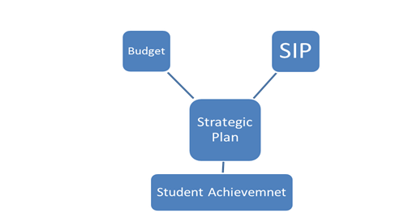

Budget Process

Executive Summary

* No cuts to instructional services
* Provides beginning teacher salary increases, as provided in the governor’s budget
* Budget covers all state law mandates (including driver’s ed.)
* 34% flows directly to the teachers
* 9% supports auxiliary services by keeping our buildings clean and safe
* 15% goes to upkeep of our buildings through our maintenance department
* Cuts
  + $41,506 Central Office Supplies
  + $9,180 Finance Contracted Services
  + $54,367 Unemployment Insurance Costs
  + $25,000 Other Contracted Services
* Employs
  + 44 teachers
  + 7.25 directors positions
  + 17 maintenance positions
  + 5 assistant principals
  + 2 social workers
  + 3 media specialist
  + 2 nurses
  + 14 teacher assistants
  + 3 Psychologist
  + .5 Behavior support assistant
  + 3 transportation personnel
* Continue to fund
  + Certified Supplements
  + Principal Supplements
  + EC Supplements
  + Coaching Supplements
  + Instructional Supplies
  + Employee assistant program
  + District wide life insurance policy
  + All insurances (volunteer/workers’ comp./etc.)
  + Instructional supplies
  + PE supplies
  + Art & Music Supplies
  + Over 1.3 million in utility expenses

This budget is balanced, consistent with our school board policies

Executive Summary



Executive Summary

